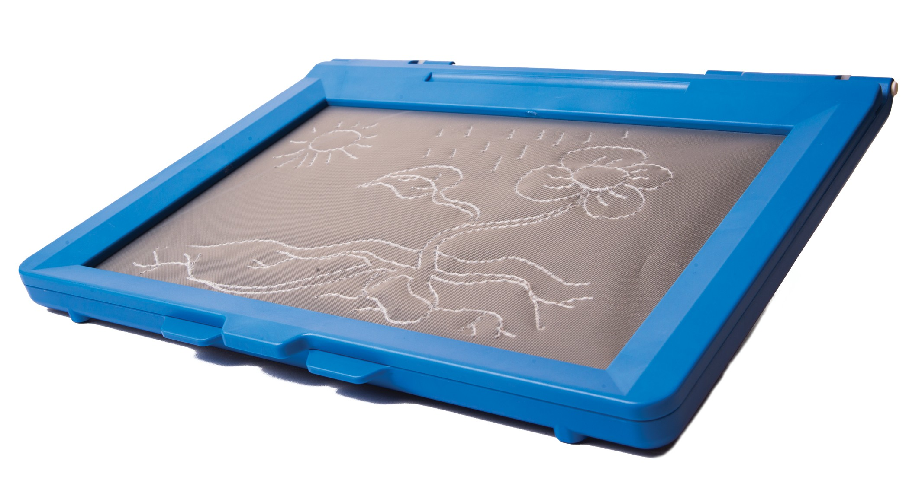

Sketchpad

User Manual

Thank You from E.A.S.Y. LLC

Hello from E.A.S.Y. LLC. You’re about to use the first product we’ve brought to market after four years of development and trial use by blind consumers and their teachers and colleagues. Before the details on how to make best use of the inTACT Sketchpad, a couple of sentences about our company. E.A.S.Y. LLC stands for “Engineering to Assist and Sup-port You”. This name really does indicate what we stand for. This product, like those that will follow, is meant to support your productivity and creativity, and to assist you by making sometimes difficult and cumbersome tasks easier.

If you have any ideas for helping future versions of the Eraser live up to the company name, please let us hear from you. You can always get in touch with us at

support@easytactilegraphics.com

To date, most of what we’ve learned has come from users, like you.

Sketchpad
E.A.S.Y. LLC
ENGINEERING TO ASSIST AND SUPPORT YOU

Table of Contents

Introduction 3
What’s in the Box 4
Familiarization 4
Getting Started 5
Creating Tactile Drawings 6
Tips for Drawing 7
Maintenance and Notes 8

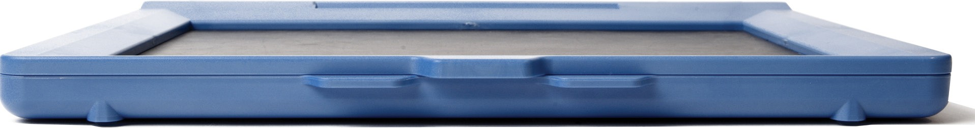

Sketchpad 2

E.A.S.Y. LLC
ENGINEERING TO ASSIST AND SUPPORT YOU

Introduction

With the inTACT Sketchpad, creating tactile graphics by hand has never been easier. As you draw with a stylus on the tactile drawing film, a raised line appears under your finger- tips, enabling you to feel your drawings as you go.

Like with a pencil, pressure and drawing angle change the height and feel of tactile lines, making shading and texture possible. The inTACT Sketchpad makes tactile drawing easier, more affordable and more powerful.

Like with any new tool or technology, perfecting the art of tactile drawing on the inTACT Sketchpad takes time and practice. The Sketchpad was designed to be straightforward and user-friendly, making this learning curve as quick and easy as possible. With the instuc- tions in this manual, and more tips / tutorials available on our website, we hope to make learning how to create and edit tactile drawings fun and easy!

Sketchpad 3
E.A.S.Y. LLC
ENGINEERING TO ASSIST AND SUPPORT YOU

What’s in the Box / Familiarization

What’s in the Box?
1 inTACT Sketchpad
1 Drawing Stylus
25 Tactile Drawing Sheets

Familiarization
When you first hold the Sketchpad in your hands, try to get familiar with the shape and size. The sketchpad is like a laptop computer, in the sense that it is hinged at the back to open and hold the drawing sheets.
Place the Sketchpad on a table or desk, orienting it with the opening tabs facing you. These tabs are located on the narrower long-side of the Sketchpad, and can be used to open and close it. You’ll notice that the middle tab is higher than the two side tabs; to open the Sketchpad, simply hold down the left or right (lower) tab, and pull up on the central (higher) tab.

Sketchpad 4
E.A.S.Y. LLC
ENGINEERING TO ASSIST AND SUPPORT YOU

Getting Started

Inserting Drawing Sheets
Inserting the Tactile Drawing Sheets is fast and easy, just follow these steps:
- Open the Sketchpad using the tabs on the front edge. Pull up on the central tab while holding down the left or right tab.
- Insert a Drawing Sheet, fitting the edges of the sheet inside of the raised edges surrounding the draw- ing area. When inserted correctly, you should be able to slide the sheet around and feel it contact all four sides of the drawing area.
- Close the lid.

Locating the Stylus
A Drawing Sheet aligned in the Sketchpad

When first using the Sketchpad, the stylus can be found inside the sketchpad frame. Open the Sketchpad, and feel for the stylus pocket near the hinge-side. The stylus feels like a pen in your hands.

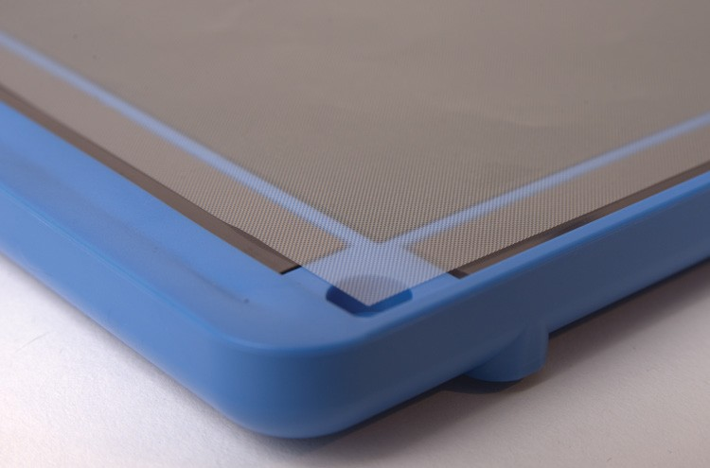Sketchpad 5
E.A.S.Y. LLC
ENGINEERING TO ASSIST AND SUPPORT YOU

Creating Tactile Drawings

First Tactile Lines
Once you’ve inserted a Drawing Sheet, and have located the stylus, you’re ready to make a tactile drawing. Hold the stylus like a pen or pencil; we recommend drawing with the pointy-end first; the rounder end requires a little more force.

When you have the stylus in hand, try making a tactile line. Do this by applying pressure and dragging the stylus along the drawing sheet. You should be able to feel a tactile line immediately as you draw.

NOTE: The angle of the stylus while drawing determines how easy or hard it is to make a raised line. Angling the stylus so that you are dragging the tip
along the plastic ("pulling" rather than "pushing") makes it much easier to make a raised line. Try holding it at different angles while drawing and see what you prefer.

Sketchpad 6
E.A.S.Y. LLC
ENGINEERING TO ASSIST AND SUPPORT YOU

Tips for Drawing

Lines of Different Heights
There are multiple ways to create lines of different heights and definitions on the Sketchpad:
Pressure: Pressing harder while drawing will create a more defined tactile line. Experiment with all levels of pressure to get a feel for the types and definitions of lines that are possible
Stylus Tip: The stylus included with your sketchpad has two ends, both of which can be used to create tactile lines. We recommend using the more pointed end for most drawing, but the rounder end can be used to create thicker, more tactile lines. With this end, however, you will need to push harder to make tactile lines.
Stylus Angle
As mentioned earlier in the Manual, the angle of the stylus while drawing has a big impact on the ease and speed of tactile drawing. The stylus should be angled so that the tip is drag- ging. For example, if you are drawing a line left-to-right, the drawing tip should be further to the left, while the other end of the stylus should be pointing up from the sheet and to the right.

Sketchpad 7
E.A.S.Y. LLC
ENGINEERING TO ASSIST AND SUPPORT YOU

Maintenance and Notes

Storage
When the Sketchpad is not in use, store in a climate-controlled environment. The Sketchpad
should always be stored in areas between 60 - 100 degrees Fahrenheit.

Durability
The Sketchpad is designed to be durable, but if dropped from more than 1 foot, damage to the hinges and/or frame may occur.

Usage Tips
For more tips, FAQs and tutorial videos related to the inTACT Sketchpad, visit

www.EasyTactileGraphics.com

Sketchpad 8
E.A.S.Y. LLC
ENGINEERING TO ASSIST AND SUPPORT YOU

E.A.S.Y.
LLC
ENGINEERING TO A T AND SUPPORT YOU

Contact Information
E.A.S.Y. LLC
210 Colchester Avenue
Burlington, VT 05405
802.448.0170
www.EasyTactileGraphics.com

Product Support
Support@EasyTactileGraphics.com

