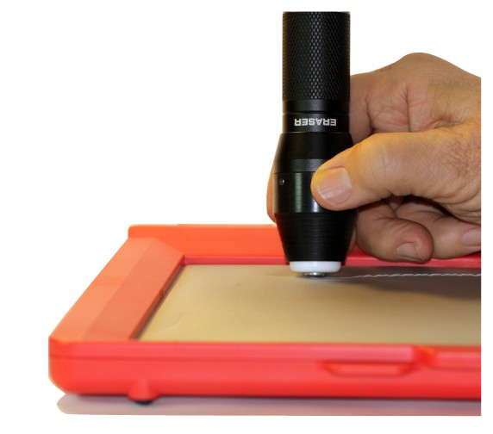

User Manual
Eraser

Thank You from E.A.S.Y. LLC

Hello from E.A.S.Y. LLC. You’re about to use the first product we’ve brought to market after four years of development and trial use by blind consumers and their teachers and colleagues. Before the details on how to make best use of the inTACT Eraser, a couple of sentences about our company. E.A.S.Y. LLC stands for “Engineering to Assist and Support You”. This name really does indicate what we stand for. This product, like those that will follow, is meant to support your productivity and creativity, and to assist you by making sometimes difficult and cumbersome tasks easier.

If you have any ideas for helping future versions of the Eraser live up to the company name, please let us hear from you. You can always get in touch with us at

support@easytactilegraphics.com.

To date, most of what we’ve learned has come from users, like you.

E.A.S.Y. LLC
ENGINEERING TO ASSIST AND SUPPORT YOU

Table Of Contents

Introduction 2
What’s in the Box 3
Familiarization 3
Changing and Loading Batteries 4
Turning Eraser On/Off 5
How To Erase 6
Notes on Erasing Quality 8
Batteries 9

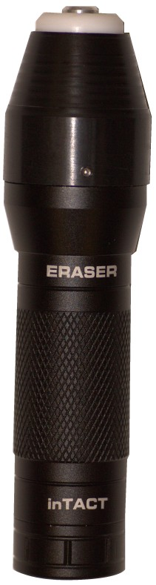
Eraser

- E.A.S.Y. LLC
ENGINEERING TO ASSIST AND SUPPORT YOU

Introduction

The inTACT Eraser is essentially a handheld battery-powered iron. It can be used to flatten raised lines you’ve scribed on the plastic sheets of your tactile graphics tablet. You can use this to correct mistakes, change lines when you have new ideas, and generally edit what you’re drawing – in short all the reasons a sighted person uses a rubber eraser to fix pencil drawings. You’ll find that you get better with it – i.e. erase more completely, consistently and selectively – with a little practice.
Warning
Do not contact Eyes or Mouth with the Eraser’s Heated Tip.
!
Do not make prolonged contact with the Eraser’s Heated Tip. Slight burning may occur.

Adult supervision recommended for use by children under 10 years old.
!

Eraser
- E.A.S.Y. LLC
ENGINEERING TO ASSIST AND SUPPORT YOU

What’s in the Box / Familiarization

What’s in the Box?
1 inTACT Eraser
4 Alkaline AAA non-rechargeable batteries ( included, to be inserted into Eraser by user.)

Familiarization
When you first hold the Eraser in your hands, before inserting the batteries, handle the unit sufficiently to become familiar with its shape and feel. Notice in particular the small flat round metal tip, protruding slightly from the conical nose of the Eraser. When heated up to operating temperature, this tip flattens raised lines. Familiarization when the unit is not loaded with its batteries, or at least when it is off and the tip is cooled to room temperature, is important since you can handle the Eraser without concern of inadvertently contacting the heated tip.

Eraser
- E.A.S.Y. LLC
ENGINEERING TO ASSIST AND SUPPORT YOU

Using the Eraser

Changing and Loading Batteries
- Unscrew the battery cap at the end of the handle farthest from the heating tip.
- Slip the battery holder out of the handle.
- Notice the ends of the battery holder are different. There's the end with a contact pin and the flat end.
- The battery holder has slots for 4 AAA batteries. Each one has a flat end (negative) and the end with a bump (positive).
- If the battery holder has old batteries that need to be replaced, remove each one carefully and recycle or discard.
- To load or re-load the battery holder, notice that each slot has a small spring at one end. Insert the flat end of each battery against this spring, and compress the spring just enough that the battery will snap firmly into place.
- Insert the battery holder into the handle so that the end with the contact pin goes in first. Screw the cap back on.
- The rubber-covered on/off button is built in the battery cap. Pushing the button should turn the Eraser on, producing a soft tone that indicates the tip is heating.

Eraser
- E.A.S.Y. LLC
ENGINEERING TO ASSIST AND SUPPORT YOU

Using the Eraser

Turning the Eraser On and Off
The on-off switch is the Eraser’s only control; it is a rubber push button. To indicate when the Eraser is on (heated up), a beeper is used. When the Eraser is on and working properly, the soft high-pitched tone will typically cycle continually – on for 3 or 5 seconds and then off for 8 to 10 seconds. This means that if there is no tone for more than 15 seconds, the unit is off.

If the Eraser has been off for more than five minutes, and has cooled to room temperature, it will take about 40 seconds to come up to operating temperature when turned on. During this period, the beeper tone will be continuous. You will know it is ready for use when the on-off cycling begins.

Eraser
- E.A.S.Y. LLC
ENGINEERING TO ASSIST AND SUPPORT YOU

Using the Eraser

How to Erase

- Hold the Eraser more or less vertical (straight up and down). This allows the flat heated tip to make good contact with the tactile drawing sheet.

- Grip it in any way that’s comfortable and natural for you. Some users find it effec- tive to hold it, pen-like, with thumb and two fingers, where the handle meets the conical tip housing. Holding it there, or even closer to the heated tip, can make it easier to know where the tip is.

- Because the nose of the Eraser is round, and because the tip is right in the middle of it, it should not be hard to learn this skill. As with any new manual tool, practice will improve results.

Eraser
- E.A.S.Y. LLC
ENGINEERING TO ASSIST AND SUPPORT YOU

Using the Eraser

How to Erase (Cont.)

- Many users find that short strokes or small circles of the Eraser across the line being erased are the most effective means of flattening a line.

- 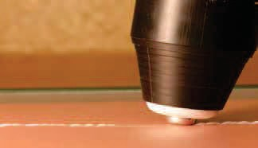You will not need to push down hard on the Eraser; its weight alone should be sufficient to produce the desired flattening. Most of the effect of the Eraser results from its elevated temperature. If you notice defor- mation or wrinkling of the drawing sheet in areas where you have erased, you are proba- bly pushing down too hard or staying in one place too long.

Eraser

An eraser rests on the plastic and is moved back-and-forth to flatten raised-lines

- E.A.S.Y. LLC
ENGINEERING TO ASSIST AND SUPPORT YOU

Notes on Erasing Quality

  - Sighted individuals will generally be able to see a residual line, even after erasing has flattened it to the point where it has nearly or completely vanished to the touch.
  - How many erasing strokes are needed to flatten a line depends in part on how firmly the line has been scribed. A thick or high or coarse – highly tactile – line may require several strokes to erase, much in the same way that heavy pencil lines can be adequately but not necessarily completely erased.
  - A very bold raised line may leave a small – though dramatically flattened – residual line after erasing, even to the touch.
  - An area where tactile features have been erased can be drawn over again up to 4 times, with no loss of raised line quality.
  - Holding the Eraser tip motionless in contact with the tactile graphics plastic sheet should be avoided; the resulting build-up of heat in one spot can produce local softening and permanent distortion of the sheet, evident by touch or by eye.

Eraser
- E.A.S.Y. LLC
ENGINEERING TO ASSIST AND SUPPORT YOU

Batteries

Battery type and management
Only AAA batteries will work with the Eraser. The Eraser is packaged with a set of four fresh (non-rechargeable) Alkaline batteries. These are the least expensive choice for replacement and provide thee hours of continuous erasing time. Turning the Eraser off when you’re not using it will let the batteries last much longer, although you will need to let the tip warm up again each time you turn it back on.

Since batteries may occasionally leak, we recommend removing them from the Eraser during prolonged non-use (more than two weeks). Especially do not store the Eraser with the batteries in it at temperatures much above room temperature. The glove com- partment in a hot car is a good example of a bad place for storage.

Eraser
- E.A.S.Y. LLC
ENGINEERING TO ASSIST AND SUPPORT YOU

E.A.S.Y.
LLC
ENGINEERING TO ASSIST AND SUPPORT YOU

Contact Information
E.A.S.Y. LLC
210 Colchester Avenue
Burlington, VT 05405
802-448-0170
www.EasyTactileGraphics.com

Product Support
Support@EasyTactileGraphics.com

